**Please read the following instructions carefully before solving & submitting assignment:**

**Uploading Instructions:**

* You are supposed to consult recommended book/s to clarify your concepts as handouts are not sufficient.
* The assignment file must be an MS Word file. Any other software/tool is not allowed.
* The required file format is **.doc** or **.docx**. Any other format like scan images, txt, pdf, png or jpeg etc. will not be accepted.
* This assignment consists of two questions. So, attempt all questions and place your solution in a single MS Word file along with your own **Student Id** at top.
* Submit the MS Word file at VULMS within the due date.

**Rules for Marking:**

It should be cleared that your assignment will not get any credit if:

* The assignment is submitted after due date.
* The assignment is not submitted in .doc or .docx format.
* The submitted assignment does not open or file is corrupt.
* The assignment is fully or partially copied from other student or ditto copy from handouts or Internet; strict disciplinary action will be taken in this case.
* The submitted file does not contain your own Student Id, or contain other than yours; Zero Marks will be awarded, and no excuse will be accepted in any case.

**Note:**

* No assignment will be accepted after the due date via email in any case (*whether it is the case of load shedding or internet malfunctioning etc.*). Hence refrain from uploading assignment in the last hour of deadline.
* It is recommended to upload solution file at least one day before its closing date.
* Do not put any query on MDB regarding this assignment, if you have any query then email at [cs606@vu.edu.pk](mailto:cs606@vu.edu.pk)

**Lectures Covered:**

* This assignment covers Lectures # 1 to 10.

**Question # 1: Marks: 10**

Draw a Transition Graph with the help of following Transition Table of a typical NFA.

|  |  |  |  |
| --- | --- | --- | --- |
|  | **a** | **b** | **ε** |
| **0** | 0, 1 | 4 |  |
| **1** | 2 | 0 | 3, 4 |
| **2** | 3 | 1, 2 |  |
| **3** | 3, 4 | 2 |  |
| **4** | 0 | 3, 4 |  |

Table: Transition Table of a typical NFA.

**Note:**

In transition table, ε represents epsilon (*i.e., empty / null input*).

For drawing purpose, you can use any drawing tool (*e.g., MS Word, MS Visio and Paint etc.*).

**Question # 2: Marks: 10**

Construct a Transition Table with the help of following Transition Graph of a typical NFA.

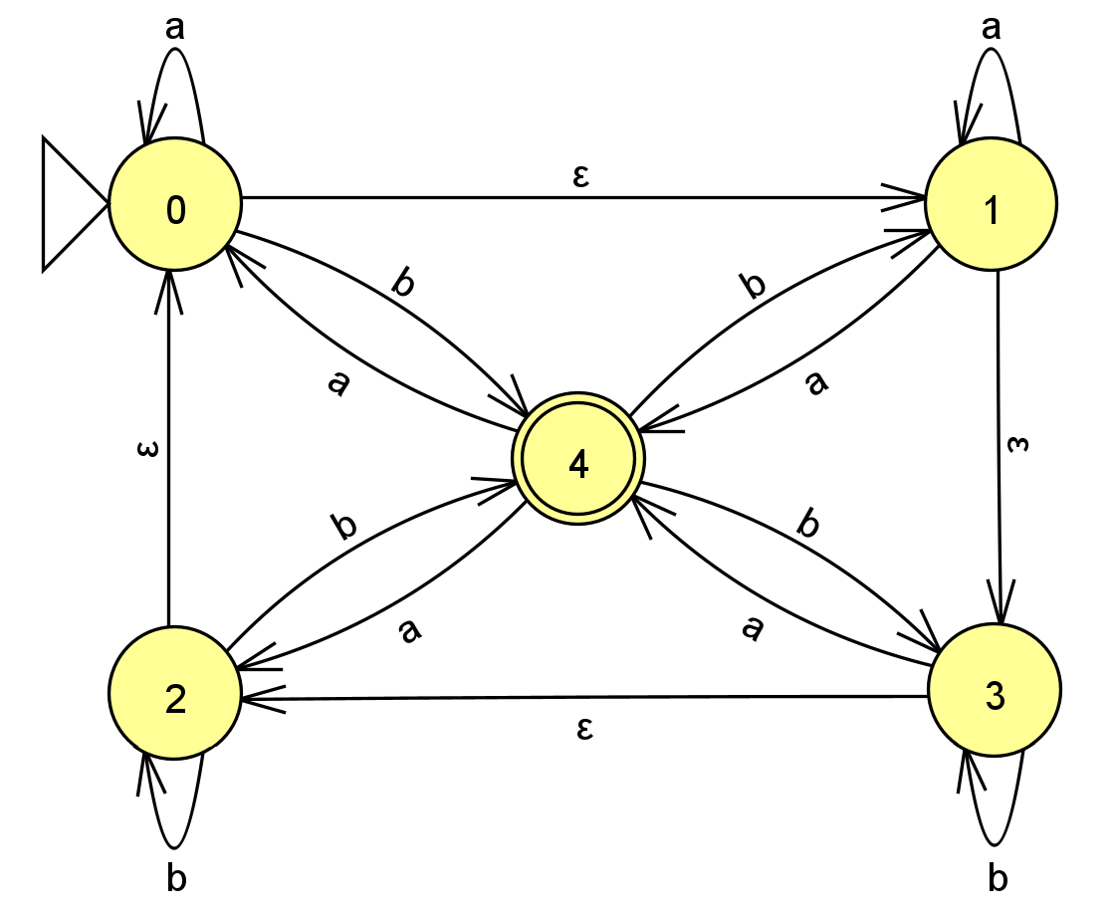

Fig. Transition Graph of a typical NFA

**Note:** In transition graph, ε represents epsilon (*i.e., empty / null input*).

Transition Table:

|  |  |  |  |
| --- | --- | --- | --- |
|  | **a** | **b** | **ε** |
| **0** | ? | ? | ? |
| **1** | ? | ? | ? |
| **2** | ? | ? | ? |
| **3** | ? | ? | ? |
| **4** | ? | ? | ? |

Table: Transition Table of a typical NFA.

Good Luck